Task 1.1: Superkey and Candidate Key Analysis
Relation A: Employee
Schema: Employee (EMpID, SSN, Email, Phone, Name, Department, Salary)

- Six Different Superkeys:

{EMpID}, {SSN}, {Email}, {EMpID, Name}, {SSN, Email}, {EMpID, SSN, Email, Phone, Name, Department,
Salary

- Candidate keys:

{EMpID}, {SSN}, {Email}, {Phone}

3. Primary Key Selection and Justification:

Selection: {EMpID}
Justification: I would choose EMpID as the primary key because it is unique for each employee and can
identify each employee easily. It is also simple, stable, and does not contain sensitive personal
information such as SSN. In addition, EMpID is more convenient to use than Email or Phone because
these values can change over time.

4. Can two employees have the same phone number?

Answer: No, based on the given data, two employees cannot have the same phone number because
each employee in the table has a unique phone number. This means that the phone number can
distinguish one employee from another in the given dataset. However, in a real database, phone numbers
should only be considered unique if a UNIQUE constraint is defined for the Phone attribute.

Relation B: Course Registration:

Schema: Registration (StudentID, CourseCode, Section, Semester, Year, Grade, Credits)

1. Minimum Attributes Needed for Primary Key:
{StudentID, CourseCode, Semester, Year}

2. Necessity of Each Attribute:
StudentID – identifies the specific student who registrered for the course.
CourseCode – identifies the specific course that the student is taking.
Section – identifies the particular section of the course.
Semester – shows the semester in which the student registered for the course.
Year – identifies the academic year of the registration.

3. Additional Candidate Keys:
There are no additional candidate keys because the combination of StudentID, CourseCode, Section,
Semester, and Year already uniquely identifies each registration. This combination is the only candidate
key for the given relation.

Task 1.2: Foreign Key Design

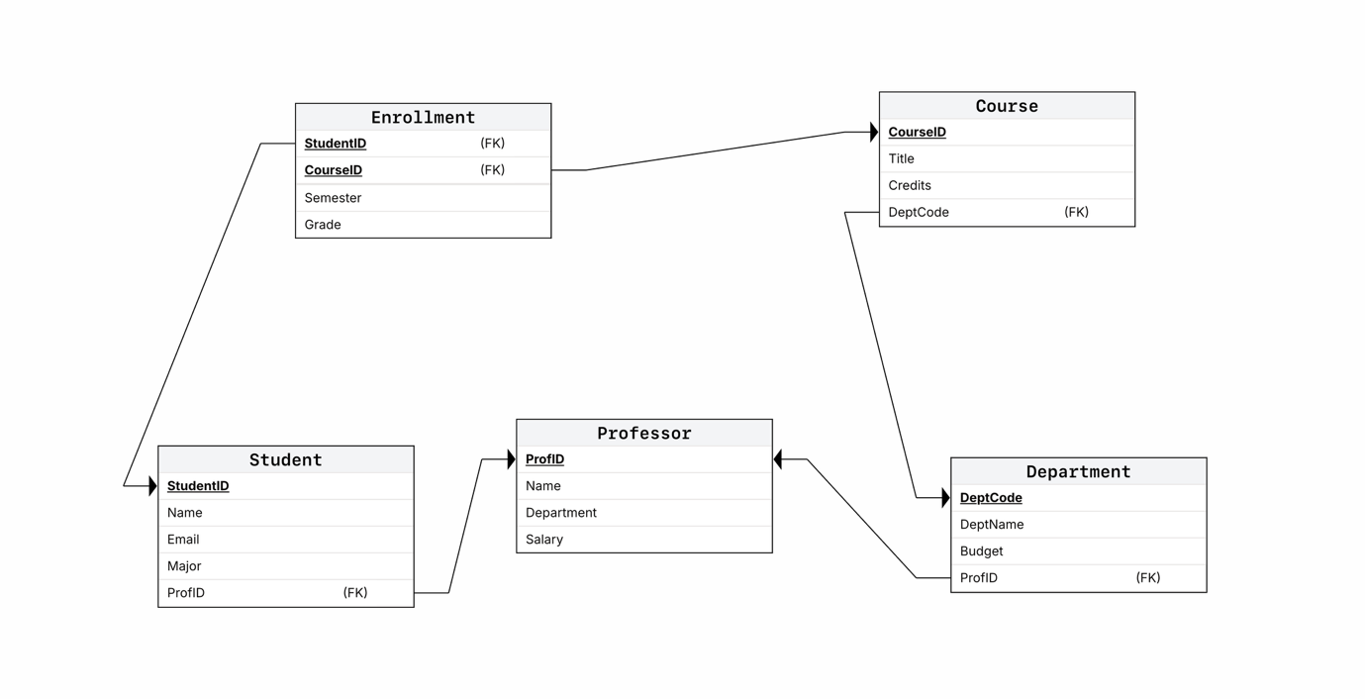

Task 2.1: Hospital Management System

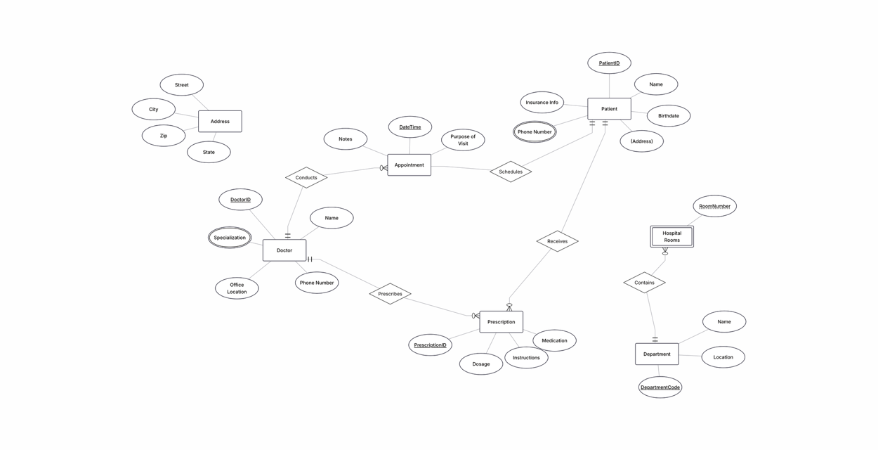

Task 2.2: E-commerce Platform

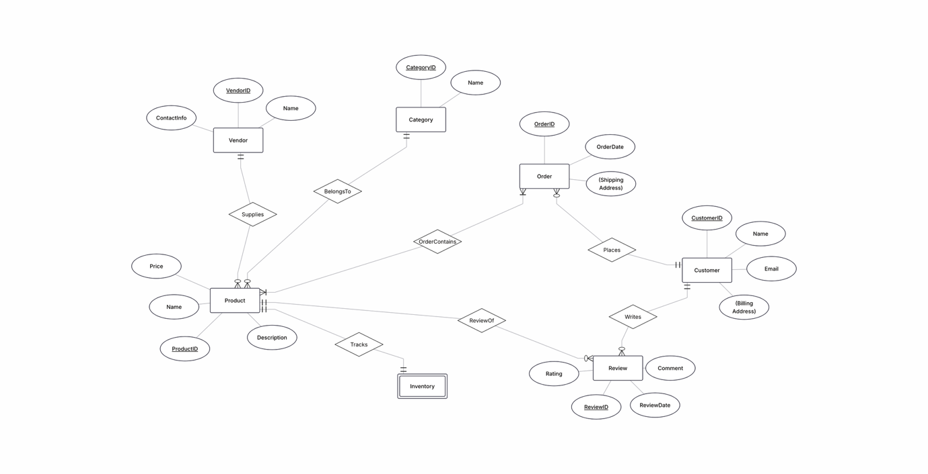

Task 4.1: Denormalized Table Analysis

1. Functional Dependencies (FDs):
2. 3. 4. 5. FD1: StudentID -> StudentName, StudentMajor
FD2: ProjectID -> ProjectTitle, ProjectType, SupervisorID, StartData, EndData
FD3: SupervisorID -> SupervisorName, SupervisorDept
FD4: StudentID, ProjectID -> Role, HoursWorked
2. Redundancies and Anomalies:
Redundancy: Student details (StudentName, StudentMajor), project details (ProjectTitle, ProjectType),
and supervisor details are dublicated for every project assignment record.
Insert Anomaly: Cannot insert a new student into the database if they are not currently assigned to a
project because (StudentID, ProjectID) forms the composite primary key (Primary Key attributes cannot
be NULL).
Delete Anomaly: Deleting a student’s project record might accidently remove the only record containing
information about that specific project or supervisor.
Update Anomaly: Updating a supervisor’s department requires updating multiple rows across the table,
risking data inconsistency.
3. 1NF Compliance:
Assuming all fields hold atomic values, the relation is already in 1NF .
4. 2NF Decomposition:
Primary Key : {StudentID, ProjectID}
Partial Dependencies FD1 AND FD2 depend on parts of the composite key.2NF Relations:
1. 2. 3. Student (StudentID, StudentName, StudentMajor) – PK: StudentID
Project (ProjectID, ProjectTitle, ProjectType, SupervisorID, SupervisorName, SupervisorDept,
StratDate, EndData) – PK: ProjectID
StudentProjectAssignment (StudentID, ProjectID, Role, HoursWorked) – PK: (StudentID, ProjectID)
5. 3NF Decomposition:
Transitive Dependency: In Project, ProjectID -> SupervisorID -> SupervisorName, SupervisorDept
Final 3NF Schemas:
Student (StudentID, StudentName, StudentMajor)
Supervisor (SupervisorID, SupervisorName, SupervisorDept)
Project (ProjectID, ProjectTitle, ProjectType, SupervisorID, StartDate, EndDate)
FK: SupervisorID -> Supervisor (SupervisorID)
StudentProjectAssignment (StudentID, ProjectID, Role, HoursWorked)
FK1: StudentID -> Student(StudentID)
FK2: ProjectID -> Project(ProjectID)

Task 4.2: Advanced Normalization

1. Primary Key :
Primary Key: {StudentID, TimeSlot}
Explanation: A student can attend only one course section in a given time slot, uniquely identifying the
tuple.
2. List of All Fucntcional Dependencies:
FD1: StudentID ->StudentMajor
FD2: CourseID -> CourseNameFD3: InstructorID ->InstructorName
FD4: Room -> Building
FD5: InstructorID, TimeSlot -> CourseID, Room
FD6: Room, TimeSlot -> InstructorID, CourseID
3. BCNF Verification:
The table is not in BCNF because functional dependencies exist where the determinant is not a superkey
(e.g., StudentID -> StudentMajor)
4.
1. BCNF Decomposition;
2. Student (StudentID, StudentMajor)
3. Course (CourseID, CourseName)
4. Instructor (InstructorID, InstructorName)
5. RoomLocation ( Room, Building)
6. CourseOffering (CourseID, TimeSlot, InstructorID, Room)
7. Enrollment (StudentID, TimeSlot, CourseID)

Task 5.1: Real-World Application

https://kbtuedu-my.sharepoint.com/:w:/r/personal/ar_bersinbaeva_kbtu_kz/Documents/bd%20lab1.docx?d=w40237e7f6d09488f8b7d6393d739adc8&csf=1&web=1&e=wqn1jx